## Dr Giles Ledlie West Practice

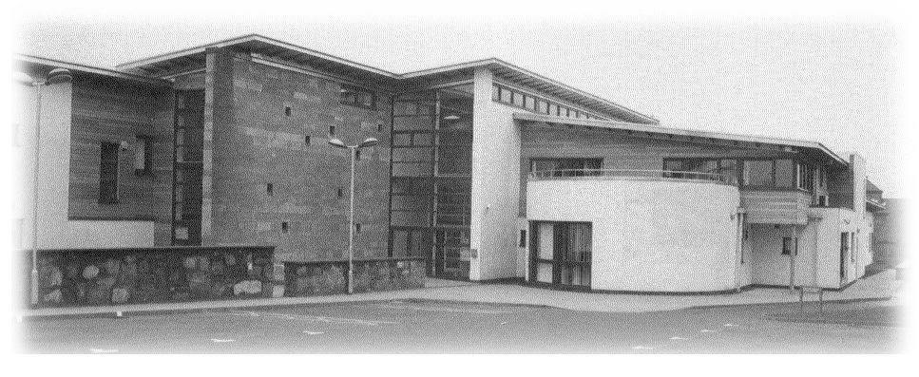

### Dr Andrew Forrester Springfield Medical Centre

## Dr Craig Nicoll 30 Ponderlaw St

## Dr Raquel Romero-Perez Arbroath

## Dr Helen Webb DD11 1ES

# Tel 01241 870307

**Medical Receptionist Vacancy (25.25 hours per week)**

Thank you for your enquiry regarding our Medical Receptionist vacancy.

We are seeking to recruit an enthusiastic and versatile receptionist to join our team working in a busy but fulfilling environment.

You will be working in a busy environment and we are looking for applicants who are enthusiastic about providing the best service for our patients.

Ideally applicants will have a good standard of general education, excellent communication skills, experience working with the public and good IT knowledge. You must be reliable, organised and a team player. Previous experience of Vision, Docman and medical terminology will be an advantage but full training will be given for the right candidate.

Hours for the post will be:

Monday 11am – 4pm

Tuesday 8am – 4pm

Wednesday 1pm – 6.15pm

Friday 8am – 4pm

Flexibility for additional hours may be required from time to time.

We hope to hold interviews the beginning of September 2025. If you have not heard from us by the end of September 2025 please assume that you have been unsuccessful on this occasion.

Yours sincerely

**Gemma Kirkpatrick**

**Practice Manager**